

School of Science, Technology, Engineering and Math

Autumn Capstone Colloquium

December 18, 2020

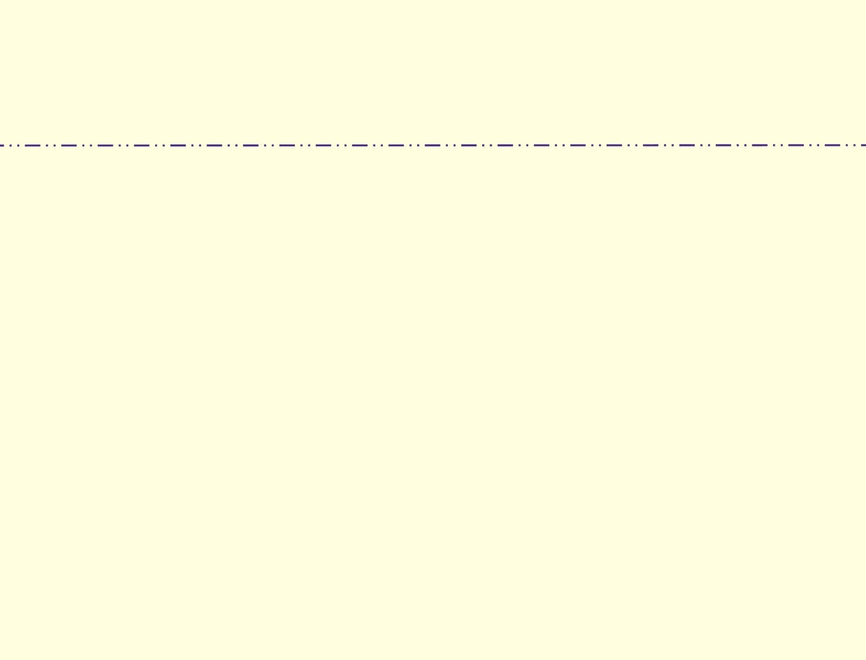

Click below to view the programs

|  |  |  |  |
| --- | --- | --- | --- |
|  |  |  |  |

Thank You to Our Industry Sponsors Who Worked Tirelessly to Support Our Students This Quarter!

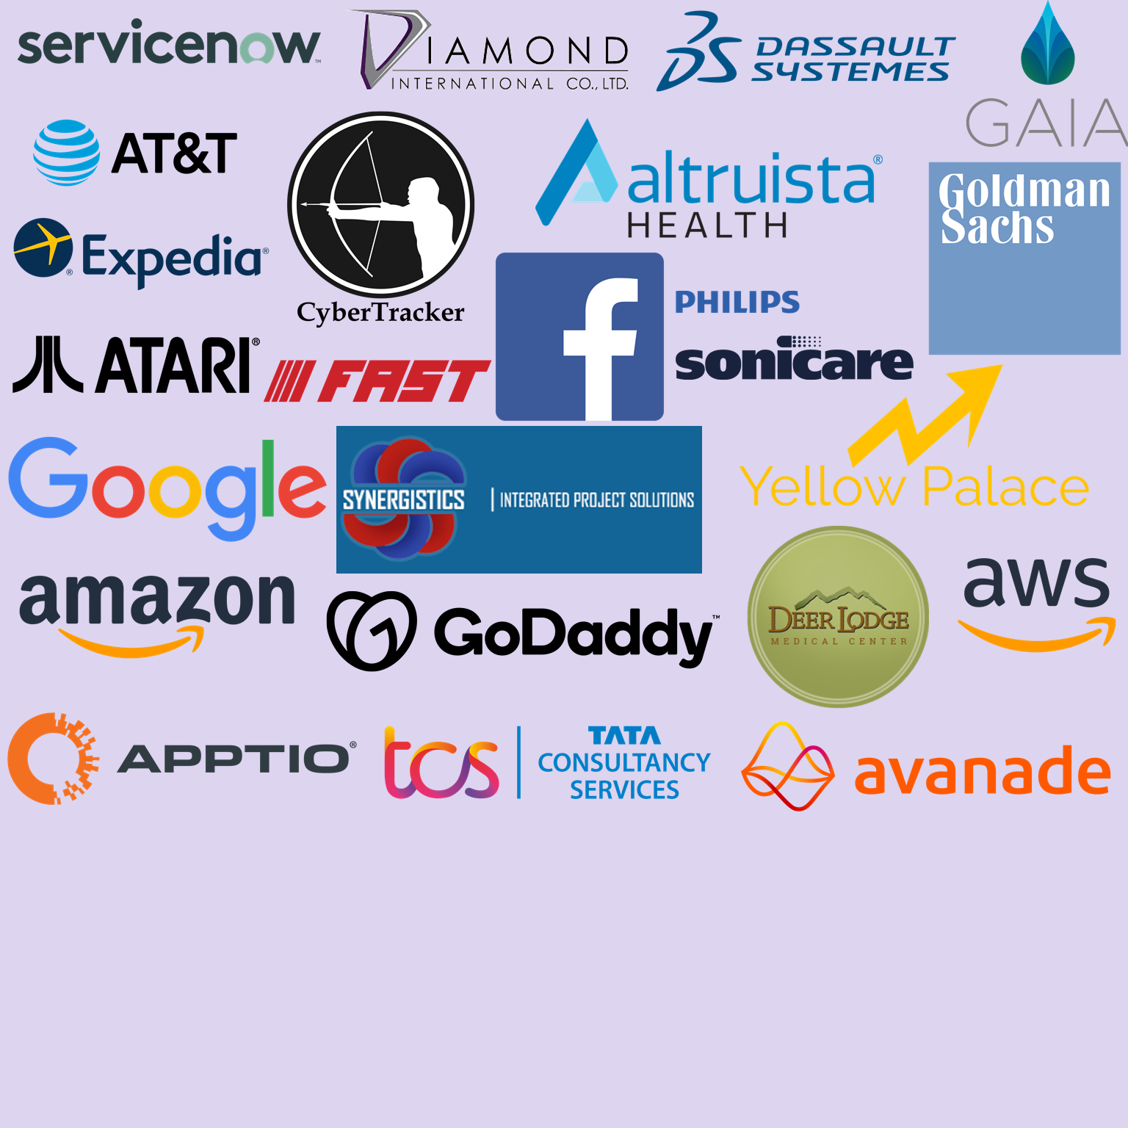

*Programs are subject to change

Updated: 12/14/2020 19:57